**Deep Learning Project Report**

**Part C**

Submitted By: Hussam-Ul-Hussain

Roll # 18L-1827

Submitted To: Dr. Usman Sadiq

Date: 22/11/2018

I’m running this project on **Google Colab** because they provide GPU for research purposes. I loaded the image data set of about 8766 images, from google drive and read through “opencv” library. Converted these images into grayscale and stored them as numpy array, in the list.

Mapped cat image labels as 1 and dog image labels as 0. After that I ran the model that was given in the project. To increase the Validation Accuracy, I had to increase **dropout**. I also added **l2 regularizer** to increase validation accuracy.

I used very low **Learning Rate of 0.0003** because I read somewhere that low learning rate would work fine for cats and dog’s dataset.

Validation Accuracy was stuck at 78-79% even after training for 100 epochs. After increasing number of filters in each Convolution Layer, Validation accuracy increased a little bit an I got 81% Validation Accuracy and 94% Training Accuracy. But still the model is overfitting a little bit.

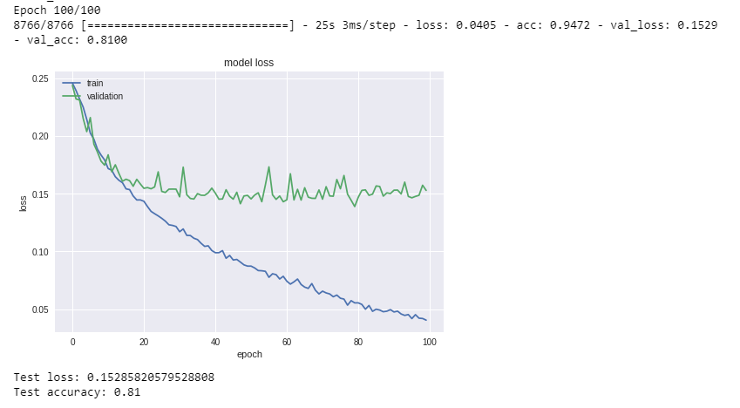

**Github link:** [**https://github.com/HussamCheema/DataScience/blob/Deep-Learning/CNN_PartC.ipynb**](https://github.com/HussamCheema/DataScience/blob/Deep-Learning/CNN_PartC.ipynb)